General & Food Waste Management (RTE).

1.What goes in what bin? Recycling rules for Ireland
We've listed all the materials in your home that can be recycled. Simply print this article out and keep it in your kitchen as a handy reference.
Paper
- Newspapers
- Magazines
- Junk Mail
- Plain Envelopes (no soft plastic)
- Paper
- Phone Books
- Catalogues
- Tissue Boxes
- Sugar Bags
- Calendars
- Diaries
- Letters
- Post-Its
- Computer Paper
- Used Beverage And Juice Cartons
- Milk Cartons
- Egg Boxes
- Holiday Brochures
- School Copy Books
- School Books (If They Cannot Be Donated Or Reused)
- Paper Potato Bags
Cardboard
- Food Boxes
- Packaging Boxes
- Cereal Boxes
- Kitchen Towel Tubes
- Toilet Roll Tubes (Please remove any plastic inserts from cardboard boxes before placing into bin)
Aluminum & Steel Cans
- Empty Deodorant Cans (Plastic Lid Separate)
- Pet Food Cans
- Food Cans
- Biscuit Tins
- Soup Tins
Plastic Containers (Containers Must Be Empty)
- Water Bottles
- Mineral Bottles
- Mouth Wash Bottles
- Salad Dressing Bottles
- Milk Bottles
- Juice Bottles
- Cosmetic Bottles
- Shampoo Bottles
- Household Cleaning Bottles
- Laundry Detergent Bottles
- Window Cleaning Bottles
- Bath Room Bottles
The below items can NOT be placed into the recycling bin:
- Nappies and Sanitary Products (including baby wipes)
- Food Waste
- Contaminated Packaging (greasy, dirty or with residue)
- Garden Cuttings / Soil
- Polystyrene (EPS)
- Liquids/ Oils
- Textiles – including clothes/shoes and home furnishings
- Dismantled Furniture
- Medical Waste
- Glass – bring this to your local bring bank
- Light Bulbs
- Electrical and Electronic Equipment i.e. anything that can contain a battery or a plug
- Batteries
- Soft plastic
- Some wrapping paper (do the scrunch test to be sure).
Top Tips
- Recycle more items from the bathroom - shower gel, shampoo, detergent, cleaning agent bottles can all be recycled.
- Rinse any food or liquid residues from containers and remove any plastic/metal inserts.
- Remove inner packaging and flatten cardboard containers to help with the recycling process and to save space in your bin.
- Do not put food waste or other compostable materials (such as soiled pizza boxes) into your recyclables bin, these materials should be placed into your compost bin.
- WEEE (Waste Electrical and Electronic Equipment – anything with a battery or a plug) can contain hazardous components and should not be placed into any household or business premise bin.
- Clothes or shoes should not be placed into your recycling bin, instead bring them to charity shops or dedicated clothes banks for recycling.
- Batteries should not be placed into bins. Batteries must be recycled appropriately and can be placed in battery boxes located in any shop that sells them.
- Know the correct collection day for your area – to ensure recyclables don’t build up and end up in the wrong bin.
For more information visit MyWaste.ie

2. Seven ways to cut down on food waste at home
It is estimated that the average Irish household throws out €400 - €1000 worth of food every year
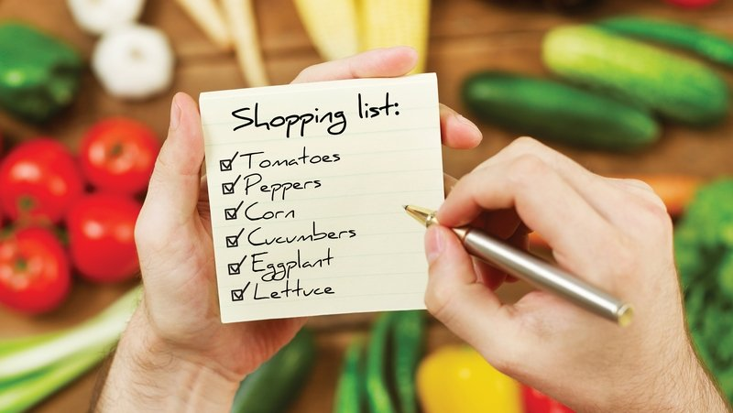
We all understand that it's not good to waste food, but did you know that cutting down on how much food you waste is a great way to help the environment. While nobody intends to waste food, often busy lives and changing plans mean that food, bought with good intentions, doesn’t get eaten. In fact, it is estimated that the average Irish household throws out €400 – €1000 worth of food every year!
On top of the financial cost, when food is wasted so too are the resources used to produce, transport and supply it. This means that food waste causes unnecessary carbon emissions, and it is currently one of the leading drivers of climate change.
The good news is that reducing our food waste isn’t actually too difficult, once you know-how. You don’t need to invest in any fancy equipment or give up the foods you love. Here are seven simple things you can do to cut down on your food waste to enjoy a healthier pocket and a healthier planet.
1. Make a shopping list
No matter what your lifestyle, there are little steps you can take to be more aware of the food you purchase. Writing a good old fashioned shopping list is a sure way to prevent food waste and save money. Before doing so, take some time to look at the food you already have and plan your shopping accordingly. Keep a notebook or piece of paper somewhere handy in the kitchen, using your phone works well too.
As you use something up, make a note of it on your shopping list. When it comes to doing the shop, you’ll already have your list written. If shopping lists are really not for you, take a 'shelfie’! Taking a photo of what you have in your fridge, freezer or cupboard before you leave the house will help remind you of what you already have and what you need.
2. Get savvy with your freezer
Making sure you correctly store your food means that, when life gets in the way, your food can get another chance. Using the freezer is one of the simplest ways to prevent food from going to waste. From batch cooked dinners and portions of soup to chopped vegetables and even eggs (without the shells), there’s almost no limit to the ways you can use the freezer to reduce waste.
Bread is one of the most commonly wasted foods in Ireland so if you sometimes struggle to finish a loaf, pop some slices in the freezer for toasting later. Buying pre-frozen vegetables is another great use of the freezer - it means you can cook the right portions without any going to waste. This is ideal for vegetables like broccoli, spinach, and squash that, when fresh, can be hard to use up. Labeling food before freezing is a great idea as you avoid ending up with Unidentified Frozen Objects!
3. Love your lunchbox
Making your own lunch saves food waste and money. You don’t have to make something especially for lunch every day, leftovers from dinner often make the perfect lunch. If you have a few carrots that’ll never get as far as the pot, chop them up and have them with something like hummus for a healthy lunchtime snack.
Storing chopped carrots in a glass or jar of water in the fridge will keep them fresh for longer. While it takes a bit of forward planning, packing lunch also helps you make healthier choices and can avoid unnecessary packaging from pre-prepared, shop-bought meals.
4. Operate a self-serve system
If you are feeding a family or group, serve food in dishes in the centre of the table and let people take what they need. Then at the end of the meal, whatever is left can be stored and served again. We're obviously much more inclined to save leftovers from a serving dish than from someone's plate. You can also work this system straight from the pots and save the extra washing up!
5. Choose foods that are local and in season
Choosing foods while they are in season reduces the resources needed to grow, transport and store them. It reduces supply chain food waste and the overall carbon footprint. Without the need for long term storage or forced growth, buying seasonal usually means buying food at its tastiest! What’s more, buying locally produced food keeps money in your community, supporting rural Irish businesses.
6. Get composting
Composting at home or using a brown bin means that food that ends up being wasted, or unavoidable food waste like orange peels, is still put to some good use. Home composting has the added benefit of providing you with an amazing free resource for your garden. If that's not for you, make sure to segregate food waste into the brown bin to ensure it goes to a commercial composting or anaerobic digestion facility. Here it will be made into soil improvers or renewable energy.
7. Be a Food Waste Champion!
It can be challenging to fight food waste solo. Do what you can to get others involved. If you're living in a house-share or if you’ve got a shared canteen at work, create a 'Please Eat Me' spot in the kitchen to make it easy to share food that may not be eaten.
If you’re eating out and have leftovers, don’t be afraid to ask to take it away for later. Talk to friends and family about the issue. The more people that start thinking about their food waste, the better for our planet.
The EPA’s Stop Food Waste programme is the national food waste prevention campaign, providing guidance and resources to help you reduce your food waste. For more on how to make the most of your food, visit the A-Z of Foods here.

3.General Waste Management
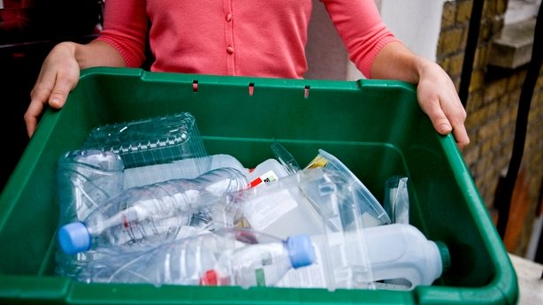
What planet are you on?'s waste management expert, Dr. Brian Kelleher, an Analytical Chemistry/School Safety Adviser at DCU, explains how we can improve our waste management at home.
The programme has already highlighted the confusion we all have about domestic waste recycling. This is compounded by non-standardised rules and regulations that vary all over the country.
Recycle, recycle, recycle.
The three types of bins provided by most but not all waste companies are:
- General waste
- Recycling (plastics paper etc.)
- Organic or compost (kitchen/food waste)
The colours assigned to bins provided by waste companies often differ, a green bin in Dublin may be a blue bin elsewhere. Some areas do not provide brown bins for organic kitchen waste and there is a lot of confusion about charges.
One family on the programme are under the impression that if they diverted all of their brown bin organic waste to the general waste (black) bin, they would save money. Trying to get information from the waste companies (of which there are approximately 60 in Ireland) can be tricky but it's worth investing the time and effort to find out where you should be putting your waste.
Not sure what objects can be recycled? Check out our handy guide here.

Do not put organic kitchen waste in general waste bin
Putting organic kitchen waste in our general waste or recycling bin is a terrible waste and turns what should be a very valuable soil amendment into a nuisance that complicates recycling and requires more energy (carbon) to treat.
It results in the emission of carbon into the atmosphere with implications for climate (a lose-lose situation). If it is placed in the composting bin, (if you are provided with one), that carbon can be locked in soil where it improves soil quality and provides nutrients, a win-win situation.
Carbon is valuable, it is much more beneficial for us to lock (sequester) it in soil rather than add to the already dangerous amounts in the atmosphere.
Similarly, organic waste that ends up in the recycling bin will interfere with the recycling process, possibly resulting in the landfilling or incineration of materials that could have been recycled. Also, the carbon ends up in the atmosphere, not soil.
Compost where you can
For those areas where no brown (organic) bin is provided, the only sustainable option is to try and compost kitchen waste. This may be difficult without a garden or backyard but not impossible.
Composting can seem a bit intimidating and its association with vermin is enough to turn many people off. There is a lot of good advice on how to produce good compost from domestic waste out there and also how to do it without attracting vermin.
I have been composting for a few years now, it definitely takes care of your kitchen waste in a carbon-neutral way but, as a keen but limited vegetable gardener, I have yet to produce anything like good compost! I am getting better though, and that is the enjoyable part.
Never ever burn your waste
Do not burn domestic waste The programme has unearthed some other interesting practices. The burning of domestic waste, in an open fire in a house is not a good idea. The temperatures reached in domestic fires are way too low (approximately 200℃) to break down toxic chemicals that may form or gasify during the combustion process.
At these temperatures there are a myriad of combustion products, including well-known dioxins that can form and be harmful to those in the house and their neighbours. I can understand the reasoning but the arguments against are far stronger:
- The toxic effects
- Combusted materials cannot be recycled and re-used.
- It results in more carbon in the atmosphere where it is harmful and less carbon where it could be beneficial.
- Plastic is made from oil. When we combust it we don't just waste this energy and carbon, we also waste the energy and carbon that was used to make the plastic in the first place….a double whammy!
- Unless the heat is turned into useable energy, carbon is simply squandered when we combust organic waste. That energy and carbon just dissipate into the atmosphere.
Drink filtered tap water
Another interesting practice on the programme was the rejection of tap water for drinking in favour of bottled water and the resultant generation of large quantities of used plastic bottles. This family have been very conscientious about recycling the plastic bottles and it results in extra visits to their local recycling centre.
I cannot verify or refute the concerns of the family (contradiction to Fiona?) here but if people are worried about tap water a good alternative would be to filter the water, the money saved on bottled water would easily offset the cost of a good filtration system.
Going forward
Advice on recycling is not difficult to find, the information is out there. However, the programme has highlighted some of the reasons why it is much more complicated than it should be.
Without a doubt, regulation is required to standardise the whole domestic waste process so that the same, sensible rules apply everywhere and there is no ambiguity about what should go where.
Regulation on its own will not work, of course, it needs to be complemented with enthusiasm and a desire to minimise our personal contributions to environmental decline.
In the meantime, things you can do to improve your household waste management include:
- Ensure you're using the correct bins
- Read up on recycling rules
- Compost where you can
- Never burn your rubbish
- Ditch the plastic bottles and drink tap water instead

- Want to cut down on your food waste at home? Check out these handy tips.

